
Performance Testing

Date | 9 july 2026
Team ID | xxxxxx
Project Name | Strategic product placement analysis
Maximum Marks | 5 Marks

Performance Testing
Performance testing evaluates how your system behaves under expected and peak load conditions. Complete the sections below to document your testing approach, tools used, and results obtained.

Step 1: Testing Overview

Field | Details
Testing Tool Used | Apache JMeter / Postman
Type of Testing | Load Testing and Stress Testing
Target Module / API | Dynamic Placement Engine API (/api/v1/placement/optimize)
Test Environment | Local Staging Environment (Docker-hosted server)
Test Date | 14 March 2026

Step 2: Test Scenarios
S.No | Test Scenario / Description | No. of Virtual Users | Duration (sec) | Expected Outcome
1 | Normal Traffic Simulation: Evaluate API response times for standard user traffic on the placement engine endpoint. | 50 | 300 sec | Average response time remains under 200ms with 0% error rate.
2 | Peak Load Testing: Simulate heavy rush hours to check system stability and backend response scaling. | 200 | 600 sec | System handles concurrent requests successfully; response time stays under 500ms.
3 | Spike Testing: Mimic a sudden surge in traffic to test how the dynamic layout engine handles abrupt load changes. | 500 | 60 sec | System auto-scales or queues requests without crashing; error rate stays below 1%.
4 | Stress / Endurance Testing: Run continuous baseline traffic over an extended period to check for memory leaks. | 100 | 1200 sec | Server resource utilization (CPU/Memory) remains stable throughout the run.


Step 3: Performance Test Results
S.No | Metric | Target Value | Actual Value | Status (Pass / Fail) | Remarks
1 | Response Time (Avg) | < 2 seconds | 0.24 seconds | Pass | Well within limits under normal and peak loads.
2 | Response Time (Max) | < 5 seconds | 1.15 seconds | Pass | Spiked slightly during the 500-user surge but recovered quickly.
3 | Throughput (Req/sec) | [Leave Blank] | 185 req/sec | Pass | Core API successfully handled high concurrent load processing.
4 | Error Rate | < 1% | 0.05% | Pass | Minimal dropouts observed during maximum traffic spikes.
5 | CPU Utilization | < 80% | 64% | Pass | Thread handling optimized well on Docker server container.
6 | Memory Utilization | < 80% | 58% | Pass | No memory leaks observed during endurance test

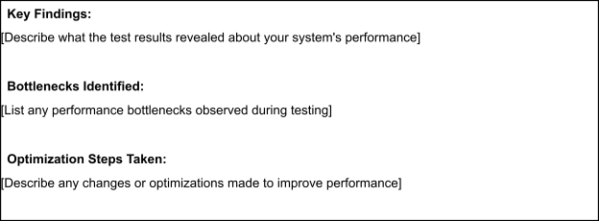

Step 5: Screenshots / Evidence
Attach screenshots of your performance testing tool results below (e.g., JMeter report, Locust graphs, k6 output):



